**Install Power BI Desktop and share the final screenshot of the report view page which appears when power desktop starts.**

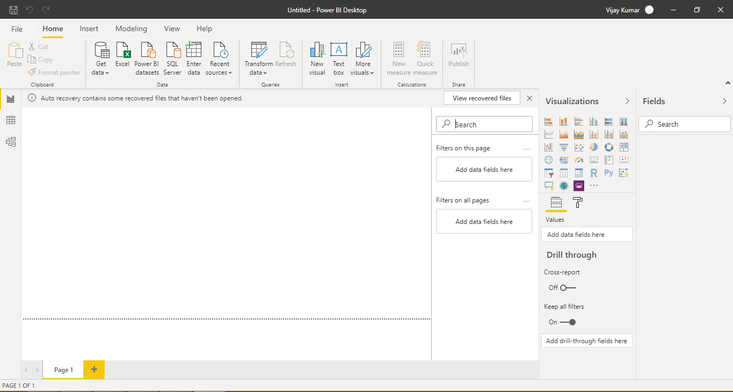

**Prepare a document and with the following screenshot**

* Report View
  + A view where we can visualize the interactive meaning full report and have visual, filter and formatting control

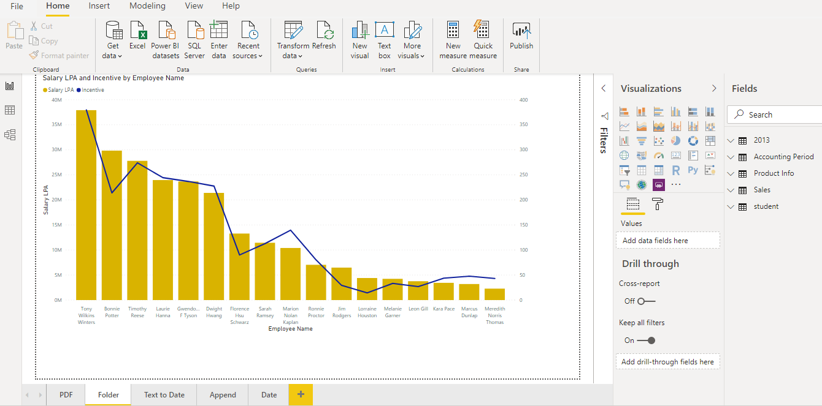

* Data View
  + It helps us to explore the data after load in model and even we can create table column, measure if required.

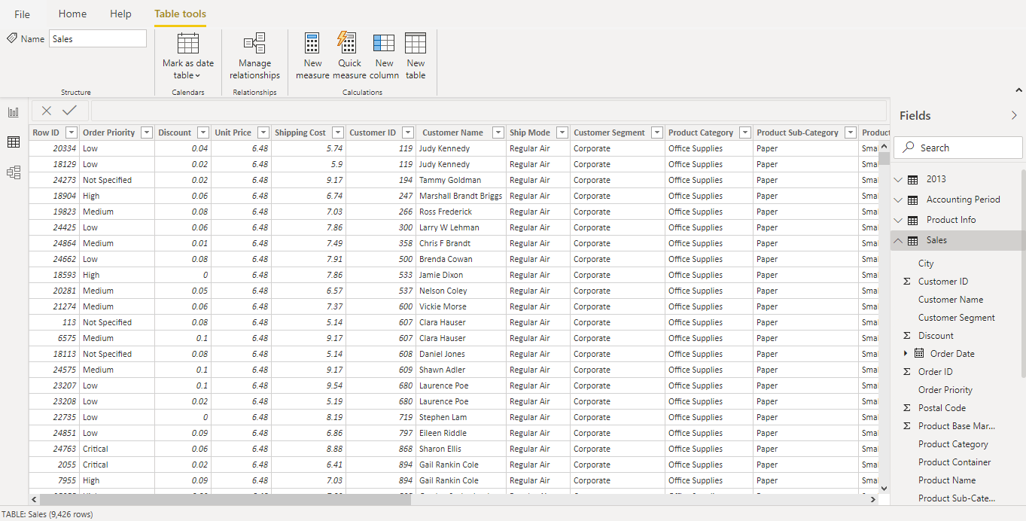

* Model View
  + Model view helps us to understand the data table and relationship among them. It makes us simple to understand complexity of data.

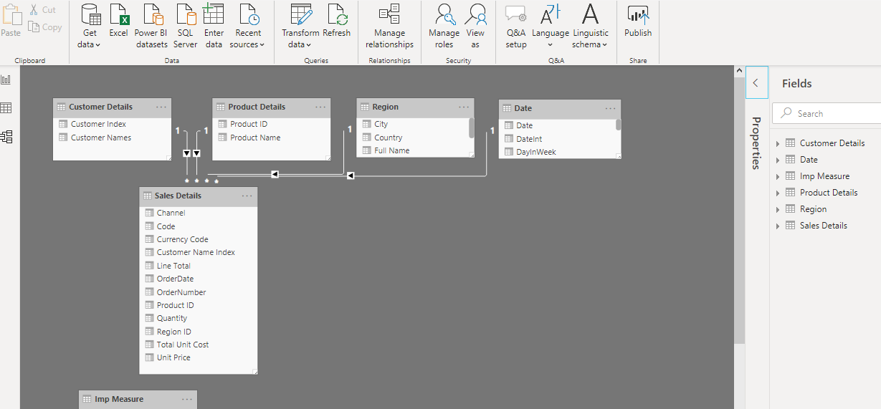

* Power Query Editor
  + It is an ETL of Power BI, we can extract the data from source, transform it and then loaded the data into tables before perform any data visualization.

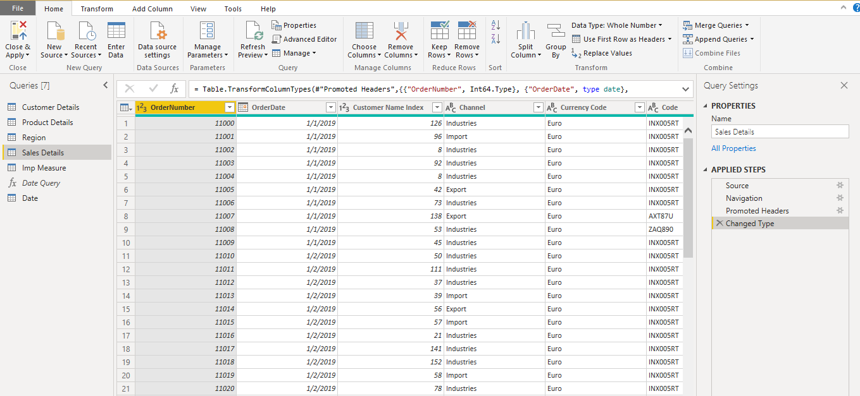

* Advance Editor
  + Advance Editor helps us to see the code behind the power query editor steps.

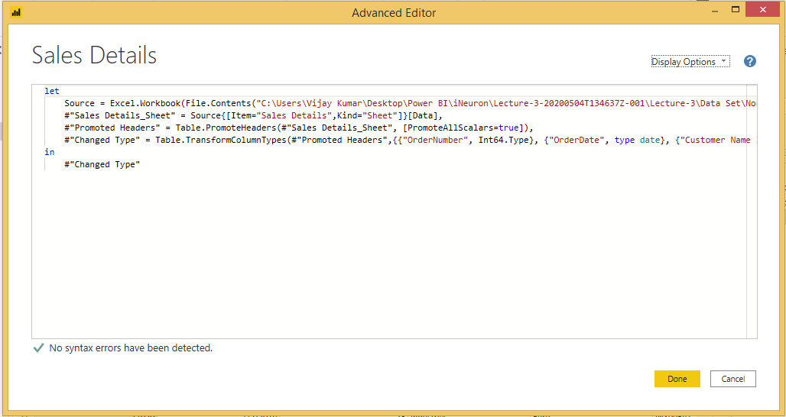

**Prepare a document with details of the following along with their price**

**Power BI Desktop**

Power BI Desktop can install on your local computer as a program, and acts as a companion desktop application to the full version of Power BI. If you need to consolidate your data sources, create your own reports and conduct your own analysis or test it’s capabilities,

* You can connect and import data from over 70 cloud-based and on-premises sources
* Auto-detect that finds and creates data relationships between tables and formats
* Export your reports to CSV, Microsoft Excel, Microsoft PowerPoint and PDF
* Python support
* Save, upload and publish your reports to the Web and the full Power BI service
* Storage limit of 10 GB per user
* Can’t share created reports with non-Power BI Pro users
* No App Workspaces
* No API embedding
* No email subscriptions
* No peer-to-peer-sharing
* No support to analyse in Excel within Power BI Desktop

Price: Free

**Power BI Pro**

Power BI Pro is the full version of Power BI, complete with the ability to use Power BI for both building dashboards and reports and unlimited viewing, sharing and consumption of your created reports

* Ability to embed Power BI visuals into apps (PowerApps, SharePoint, Teams, etc)
* Native integration with other Microsoft solutions (Azure Data Services)
* Share datasets, dashboards and reports with other Power BI Pro users
* Can create App Workspaces and peer-to-peer sharing

Price: 660 INR per month for a user

**Power BI Premium**

Power BI Premium is the most expensive tier of Power BI currently available and very distinct from the other two versions available on the market.

On top of the features and functionality standard to all versions of the service, users of Power BI Premium get:

* Increased data capacity limits and maximum performance
* Access to one API surface
* Ability to embed Power BI visuals into apps (PowerApps, SharePoint, Teams, etc)
* Larger storage sizes for extended deployments
* Geo distribution, higher refresh rates, isolation, pin to memory, read-only replicas
* Power BI Report Server

Price: 330190 INR per month for an enterprise